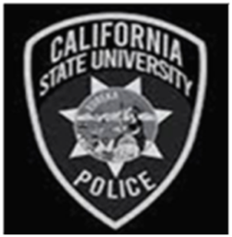

**DEPARTMENT STAFFING**

**25** Sworn Personnel

**6** Dispatchers

**10** Administrative Professionals

**9** Campus Safety Specialists

**45** CSOs (Students)

*As of December 2024